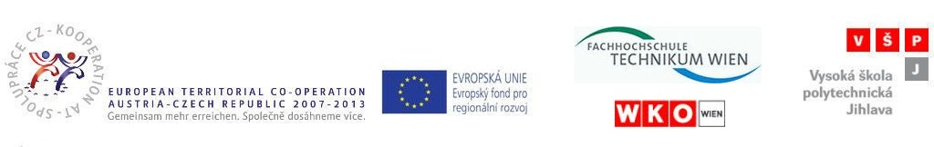

In Jihlava, 5th August 2010

Minutes of the meeting with the Austrian partner FHTW

Term of meeting: 5th August 2010
Location: College of Polytechnics Jihlava

The meeting with our Austrian partner FHTW took place at the College of Polytechnics Jihlava on 5th August 2010. Subject matter of the meeting was following:
- work practical experiences for students from FHTW in Vysocina region
- To arrange of work placements for students in companies
- To arrange of accommodation and meals for the students
- To arrange of supplementary programme
- work practical experiences for students from VSPJ in Vienna and St. Pölten
- workshop after ending of work practical experiences of the Czech partner students in Vienna and St. Pölten
- materials for the monitoring report 2 (at the project level) for monitoring period 2

